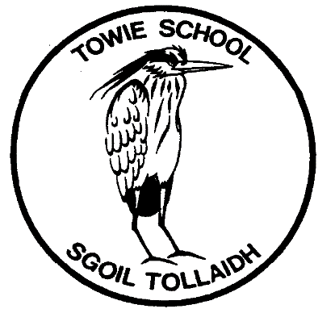

TOWIE SCHOOL

is a happy, caring, friendly place
where the children work in a creative,
stimulating environment.

We want you and your children to enjoy your
time at Towie School.

INFORMATION FOR PARENTS

Starting school – We want your child to settle into school as easily as possible. All staff work together to care for your child and to create a safe and stimulating environment for your child to develop as an individual. We work in partnership with parents to ensure that every child develops to his/her full potential.

Curriculum for Excellence (CfE) – The school’s priorities lie in developing literacy and numeracy, and in looking after the children’s health and well-being. Using the ‘outcomes and experiences’ from CfE, we are working with the children to develop skills for learning, life and work. We aim to make the learning relevant and to link knowledge in one subject area to another, helping the children to understand the world and to make connections.

Child Protection
All Towie School staff receive Child Protection training and are PVG disclosed.

Safety - The safety of children at Towie is paramount and extreme care is taken to ensure that this is always the case. Risk Assessments are carried out for school trips and events.

The School Day
Start 9.15 a.m.
Morning Break 10.45 a.m. – 11.00 a.m.
Lunch Break 12.30 p.m. - 1.30 p.m.
Finish 3.30 p.m.

Emergency Contact – In the event of an emergency, contact will first be made with parents and thereafter with emergency contacts.

Home/School Contact - If at any time you wish to talk with the Class Teacher or the Head Teacher about an issue which has arisen, please email or phone the school.

Absence from school - Please inform the school by e-mail or by phone (in advance) of your child's absence from school. We must account for all children and we will need to contact you if we have not heard and your child does not appear in school.

Medicines - Any medication must be clearly labelled with your child's name and a written set of instructions on dosage etc. This MUST be handed over to the office staff and the appropriate paperwork must be filled in.

Illness at school – If your child becomes unwell during the school day, we will contact you or, if we cannot get hold of you, the person you have chosen as your emergency contact.

Drop-Off / Collection from school – The school must be kept informed of any changes to arrangements for collecting your child from school. You can inform the teacher directly or e-mail the school, but please phone if you do not receive an acknowledgement of your e-mail.

Behaviour Management - We hope to build self-esteem and standards of behaviour through a restorative approach.

Bullying - At Towie School, it is seen as the duty of all staff, pupils and parents to do all we can to eliminate this unacceptable practice.

School Transport - All primary pupils who live more than two miles from and attend the school for which they are zoned are entitled to free school transport. Pupils will be allocated an appropriate pick-up/drop off point from the Public Transport Unit.

Snacks – We would encourage you to give your child a healthy snack for break-time and a water-bottle.

School Meals - School meals are free for Primary 1 to 5 pupils. The Council uses an online system of payment called iPayImpact – you will be given a code for this when your child starts. The School Menu can be found on the Aberdeenshire Council Website for parents to discuss choices with their children. School Meals - Aberdeenshire Council Alternatively, children may bring their own packed lunch. Drinking water is available each day, but pupils should bring their own water bottle.

Uniform – School uniform orders should be placed directly with our supplier:
Towie Primary – Schoolwear Made Easy

The recommended school uniform is:
- Sweatshirt - red
- Grey or black trousers / shorts / skirt
- White shirt/polo shirt or blouse
- Sensible shoes with easy fastenings
- Some girls wear gingham dresses during warm weather

For PE
- Shorts
- T-shirt or polo shirt (No football strips)
- Gym shoes – pull on
- Gym bag e.g. draw string bag

For Homework
- Reinforced plastic wallets for homework will be provided by school.

For Art
- Overall – an old adult shirt or t-shirt is recommended

Please Note: Nail varnish is not allowed in the school and for safety only stud earrings may be worn.

Please make sure everything your child brings to school is clearly labelled with their name and class, not just initials.

Parent Council - Please get involved with the Parent Council, if you can. The Parent Council meetings are an opportunity for you to express your views and to bring improvements within the school, but also allow you to support with fundraising and school events. It’s a great way to meet other parents too!

First day of school - If eligible for school transport, you will receive a bus pass with pick-up information during the last week of the summer holidays. If bringing your child, please arrive at the playground for about 9.10 am and they will be met by their new teacher.
The Primary 1/2/3 Teachers for 2022 – 2023 are: Mrs Main (Mon/Tue/Wed) and Miss Fowlie (Thur/Fri).
The teacher for P4567 is Miss Anderson.

All pupils will start full days from Tuesday 22nd August 2023

We look forward to your child starting with us. Please contact me if you would like to discuss any of these items further.

Thank you.

Ken Girdwood – Acting Head Teacher

